REPORT

### **Secure File Storage System Using AES Encryption**

#### **Name: Kritika Sharma**

#### **Date: 27th June, 2025**

### **Objective**

To create a secure local file storage system using AES encryption in Python, allowing users to encrypt files and store metadata to ensure data confidentiality and integrity.

### **Tools Used**

* Python 3.10+
* cryptography (Fernet)
* Command Line (CLI)
* Windows OS
* JSON
* hashlib (for SHA-256 hash)

### **Project Workflow**

1. **Key Generation** generate_key.py creates a secure AES key and saves it as mykey.key.
2. **File Encryption** encrypt_file.py:  
   * Takes a file name as input
   * Encrypts it using the key
   * Saves the encrypted file in the encrypted_files/ folder
   * Stores metadata like file name, path, hash, and timestamp in metadata.json
3. File Decryption using a matching decryption script.

### **Folder Structure**

SecureFileStorageAES/

├── generate_key.py

├── encrypt_file.py

├── mykey.key

├── metadata.json

├── encrypted_files/

│ └── test.txt.enc

### **🔐 Sample Metadata.json**

{

"file_name": "test.txt",

"encrypted_file": "encrypted_files/test.txt.enc",

"timestamp": "2025-06-27T19:24:01.123456",

"hash": "73d2aef674a9bd9e7a08a761f0bfbda3cb9c0a95ed..."

}

Screen shots:

CMD showing successful encryption

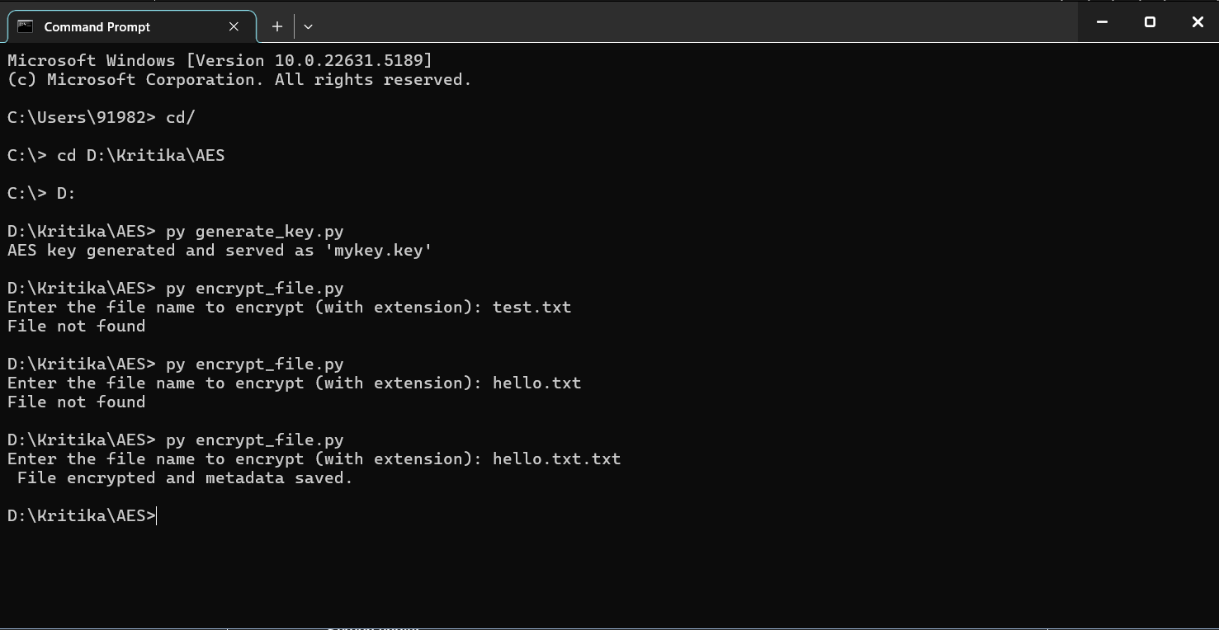

Folder showing encrypted file + key

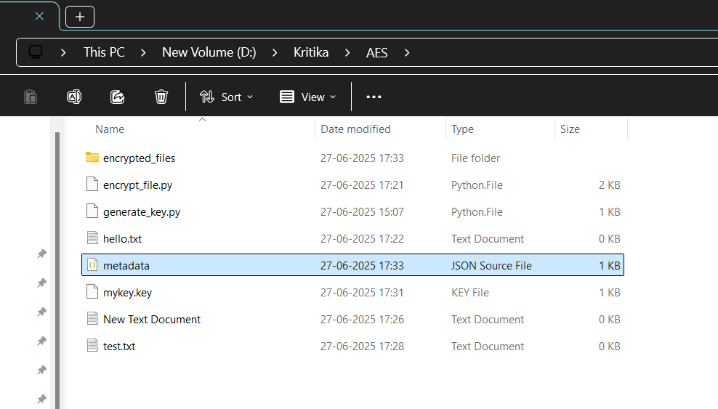

Contents of metadata.json

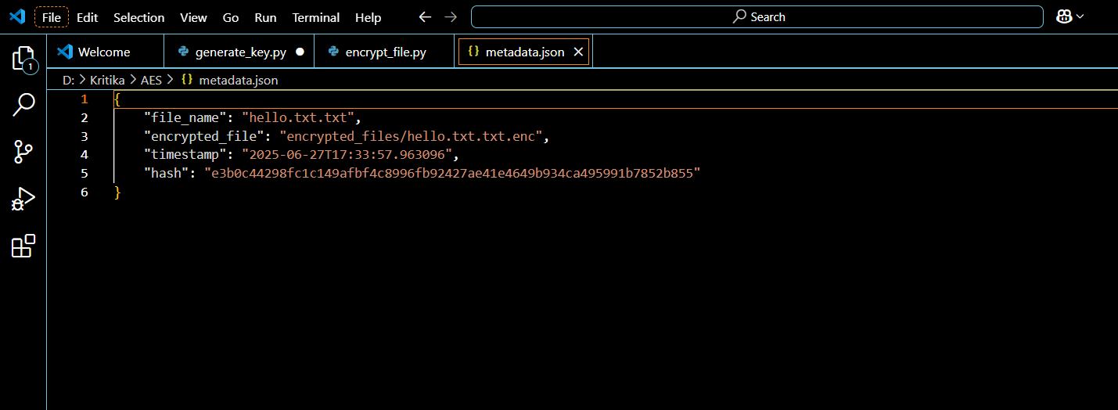

### **Learning Outcomes**

* Understood AES-based encryption using Fernet
* Gained hands-on experience in Python file handling and hashing
* Learned how cryptographic tools are applied in secure systems
* Built a complete mini cybersecurity project

### **Conclusion**

This project successfully demonstrates secure file encryption and metadata handling using Python. It can be enhanced with password-based decryption, GUI (Tkinter), and cloud storage in future versions.

### **References**

* <https://cryptography.io>
* <https://docs.python.org/3>
* YouTube: Learning with Sid (AES File Encryption)